Day1:
- Understood the RTOS fundamentals from the link below.
- RTOS is a Real-Time OS that works with real-time constraints.
- RTOS Fundamentals
  - Multitasking
      - Multiple tasks (threads) execute at the same time
      - Complex Multiple Tasks can be divided into smaller reusable tasks, making software testing easy and removing sequencing details.
      - Multitasking Vs Concurrency
        - The image below shows the execution of multitasking, but there is some time difference in the execution of all the tasks.
        - Multitasking
        - Each executing program is a task or thread. If an OS can execute multiple tasks, then it is called multi-threading.
        - Multitasking and inter-communication allow complex applications to be partitioned into smaller, manageable tasks.
        - Complex timing and sequence can be removed from the application and becomes the responsibility of OS.

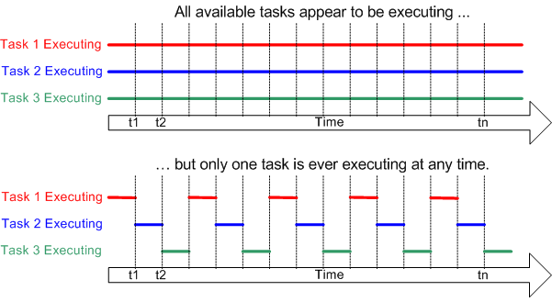
        - Concurrency
        - It is the execution of multiple instructions at the same time.
        - The running process always communicates with other threads through shared memory.
        - With the current technology such as multi-task core processors and parallel processing, it is possible to run multiple threads at the same time.
        - It is used in web servers and multimedia applications.
        - Advantages: Better performance, running multiple applications, better resource utilization
        - Limitation: Deadlock, Complexity in oS, Running too many applications leads to degradation in the performance

    - Scheduling
      - The scheduler is the part of the kernel that decides which task to execute at that particular time
      - The scheduling policy is the algorithm used by the scheduler to decide which task to execute at any point in time.
      - The below image shows the scheduling of the task
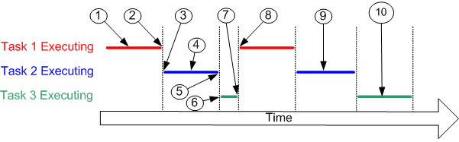
Referring to the numbers in the diagram above:
- At (1) task 1 is executing.
- At (2) the kernel suspends (swaps out) task 1 ...
- ... and at (3) resumes task 2.
- While task 2 is executing (4), it locks a processor peripheral for its own exclusive access.
- At (5) the kernel suspends task 2 ...
- ... and at (6) resumes task 3.
- Task 3 tries to access the same processor peripheral, finding it locked task 3 cannot continue so suspends itself at (7).
- At (8) the kernel resumes task 1.
- Etc.
- The next time task 2 is executing (9) it finishes with the processor peripheral and unlocks it.
- The next time task 3 is executing (10) it finds it can now access the processor peripheral and this time executes until suspended by the kernel.
      - The purpose of the scheduling algorithm is to
        - Maximum CPU utilization
        - Maximum throughput
        - Minimum waiting time
      - Types
        - First come first serve
          - FCFS supports non-preemptive and preemptive CPU scheduling algorithms.
          - Tasks are always executed on a First-come, First-serve concept.
          - FCFS is easy to implement and use.
          - This algorithm is not very efficient in performance, and the wait time is quite high.
        - Shortest Job first
          - Shortest Job first has the advantage of having a minimum average waiting time among all operating system scheduling algorithms
        - Round robin
          - Round robin is a preemptive scheduling.
          - Round robin is a preemptive scheduling. All processes are executed in a cyclic way.
          - Each process provided a fixed time slice for execution
          - Once the process is executed another process is preempted and another process executes for a fixed amount of time.
          - Context switching is used to save and restore a stack.
        - Priority Based Scheduling
        - Shortest Remaining time first
          - The process with the shortest remaining time gets the CPU first
    - Context Switching
      - The process of saving the context of a task being suspended and restoring the context of a task being resumed
    - Real Time Applications
      - A real-time application is a type of software system that must meet specific timing constraints to function correctly
      - It executes a task in real time
    - Real Time Scheduling
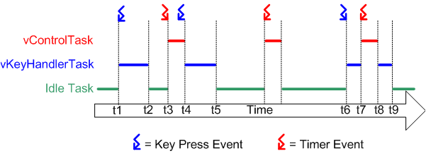

- Understood the RTOS fundamentals from the link below.
- Understood FreeRTOS Kernel Developer Docs
  - Tasks
    - Task States
      - Running
      - Ready
      - Blocked
      - Suspended
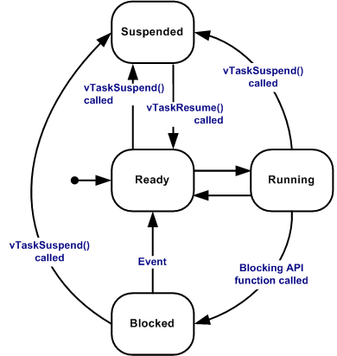
    - Task Priorities
      - All task Priorities are set to 0 to ( configMAX_PRIORITIES - 1 ), configMAX_PRIORITIES defined in FreeRTOSConfig.h
      - A low-priority number denotes a low-priority task.
      - If configUSE_TIME_SLICING is set to 1 then all task has the same priority.
    - Implementing (writing) a Task
    - The Idle Task and Idle Task Hook Function
      - The Ideal task has no priorities
      - created automatically when the RTOS scheduler is started to ensure there is always at least one task that can run
      - responsible for freeing memory allocated by the RTOS to tasks that have since been deleted.
      - vTaskDelete() is used to delete tasks created.
  - Queues, Mutexes, Semaphores…
    - Queues
      - It is intertask communication. Used to send messages between tasks and between interrupts and tasks.
      - xQueueCreate(QUEUE_LEN, sizeof(int));
      - (xQueueSend(msg_queue, (void *)&num, 0)
      - (xQueueReceive(msg_queue, (void *)&item, 0)
      - Queue can hold the data or pointer to the data.
      - Data are directly copied to the queue.
      - Queues are a FIFO buffer where data is written to the end of the queues and removed from the front.
      - Queue can be used as a semaphore, mutex, or event flag.
      - The queues model manages simplicity and flexibility.
      - Operation in queue: Create, Read, Write
    - Semaphores
      - Semaphores use a signaling mechanism for synchronization. A semaphore is typically an integer variable S which is initialized to a total number of resources available. The value of Semaphore can be changed by SIgnal() and wait() functions.
      - We should create a semaphore before using it.
      - When the process is modifying the number no other process are allowed to use it.
      - They are categorized into 2 semaphores.
      - Binary Semaphores
        - In the Binary semaphore, the value of the semaphore should be 0 and 1.
        - It is similar to mutex but mutex works on the locking mechanism and binary semaphore works on the signaling mechanism.
        - When the task wants to access a resource it will perform a wait function and make value to 0.
        - When it releases it performs signal operation on the semaphore and increments to 1.
        - 0 means busy and 1 means free.
        - Here 0 means the thread is in the critical section and other threads should wait to complete.
        - 1 means no thread is accessing the shared resources.
        - It can guarantee mutual exclusion. Since only one thread can enter a critical section at a time.
      - Counting Semaphores
        - In counting semaphores value of a semaphore can be a number of resources available in the system. When the task wants to access a resource it performs a wait function on the semaphore and decrements to 1. When the task is free it sends a free function and increments the count by 1.
        - When the semaphore count is 0 that means all resources are busy.
        - A task needs to wait to access the resource.
        - Counting Semaphores are typically used for counting events and resource management.
      - Difference between Semaphore and Mutex: https://techdifferences.com/difference-between-semaphore-and-mutex.html
    - Mutexes,
      - Mutex is shortly termed mutual exclusion which works on a locking mechanism.
      - The thread that has taken mutex can only release the mutex when it exits from a critical section.
      - There is an ownership associated with mutex.
      - If there is a single instance for resource then it is better to use mutex.
mutex = xSemaphoreCreateMutex();
if (xSemaphoreTake(mutex, 0) == pdTRUE)
xSemaphoreGive(mutex);
Definition :
Resource: Entity used by a task. It can be I/O devices such as keypads, displays, etc.
Preemptive RTOS: It can stop low-priority interrupts and can execute high-priority interrupts.
Kernel: It is part of the OS responsible for task management and communication between tasks.
Priority inversion - Low-priority task blocks high-priority tasks due to resource locking in mutex and semaphore.
Priority inheritance: Low priority task is automatically assigned to higher priority task when it blocks on mutex. When the mutex lock is released task will be assigned to the original priority.
Deadlock: A deadlock is a situation where a set of processes is blocked due to each process holding a resource and waiting for another resource that is acquired by some other process. Deadlock can arrive if Mutual exclusion, hold and wait, circular wait.
SpinLock: Spinlock is a locking mechanism for process synchronization. It allows a thread to wait in the loop until the lock is available.
https://www.geeksforgeeks.org/difference-between-spinlock-and-semaphore/
Starvation in OS: Starvation is a problem of resource management where in the OS, the process does not have resources because it is being used by other processes.
This problem occurs mainly in a priority-based scheduling algorithm in which the requests with high priority get processed first and the least priority process takes time to get processed.
It is a problem when the low-priority process gets jammed for a long duration of time because of high-priority requests being executed.
Resources needed for the Operating system to handle requests of the process:
- Memory
- CPU time
- Disk space
- Bandwidth of the network
- I/O access to disk or network
Starvation in OS
Bit banging: It allows a device to implement different protocols with minimal or no hardware changes.
Crash Issue:
- Segmentation Fault: It is the major reason for program to crash. These are may be the reasons for the such cause
  - Attempting to access memory location that doesn’t exist in our system.
  - There may be an attempt to write on a read only memory location.
- Stack Overflow: There may case of non terminating recursion with memory location
- Buffer Overflow: It is an anomaly where a program while writing data to a buffer, overruns the buffer’s boundary and overwrites adjacent memory locations.
- Memory Leak: If we allocate some memory by some program and let it be as it is. After sometime there will be huge memory that is allocated but not used so this would lack of memory after sometime. And thus program start crashing.
- Exceptions
  - Divide by zero.

Scheduling Methods:
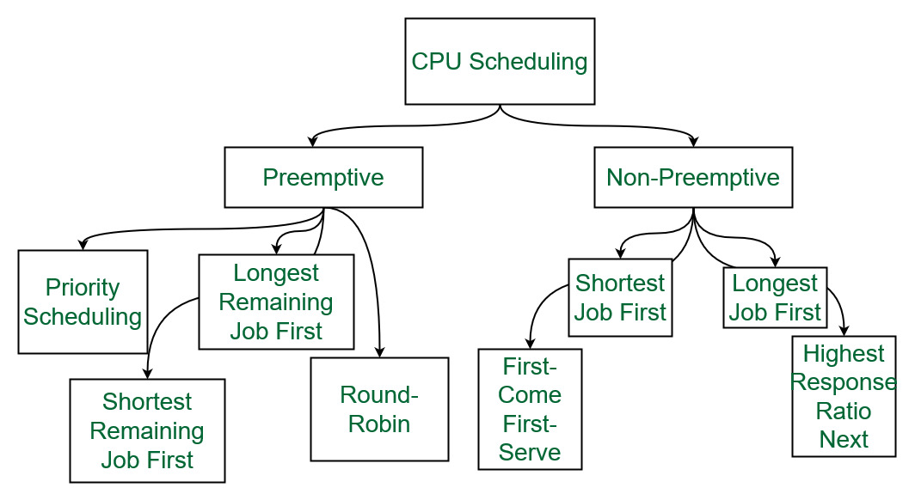
https://www.geeksforgeeks.org/cpu-scheduling-in-operating-systems/
Feature | Preemptive Scheduling | Non-Preemptive Scheduling
Interrupts | Allows interruptions | No interruptions
Flexibility | Flexible, allows for quick response to high-priority tasks | Rigid, current process runs to completion
CPU Allocation | The CPU can be taken away from a process | The CPU is allocated until the process completes
Overhead | Involves context switching overhead | No context switching overhead
Examples | Round Robin, Priority Scheduling | FCFS (First Come First Serve), SJF (Shortest Job First)

Difference between Baremetal and FreeRTOS
Baremetal vs Free RTOS
Parameters | Baremetal | Free RTOS | Linux
Definition | Runs directly on Hardware | Designed for users to manage Task scheduling, IPC, and Hardware abstraction easily | Designed to give a user-friendly experience and manage Task scheduling, IPC, and Hardware abstraction easily
Complexity | Less complex | More complex than Baremetal | Less complex
Determinism | Challenging | Tasks meet strict timing requirements | Possible
Resource Management | Need to implement it from scratch  Not easy | Manageable | Manageable
Code Size | Low | More | More
Portability | Not Easy | Medium | Easy
Development Time | More | Less | Medium
Efficient Memory Usage | Yes | Yes | No
Good for small devices | Yes | Yes | No
Level of application Hardware | Complete | Medium | None
Ability of multi-task | No | Yes with 100% separation | Yes
Community support | No | Yes | Yes
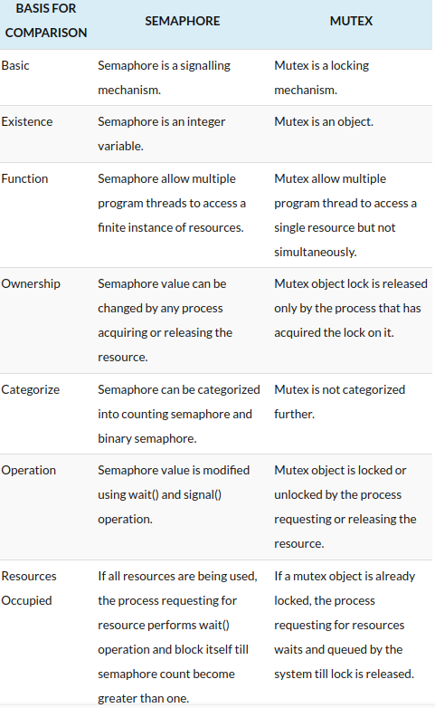
Semaphore Example Link
Semaphore Example with Game Example
Practical example using semaphores (Login Queue)
—----------------------------------------------------------------------------------------------------------------------------
What is Burst Time:
In the context of CPU scheduling and operating systems, "burst time" (BT) refers to the total time a process requires to execute on the CPU.
What it is:
- Burst time is the amount of CPU time a process needs to complete its execution.
Context:
- It's a key factor in CPU scheduling algorithms, which determine how the CPU allocates its time among different processes.
Related terms:
- Arrival Time (AT): The time at which a process arrives in the ready queue.
- Completion Time (CT): The time at which a process finishes its execution.
- Turnaround Time (TAT): The time difference between completion time and arrival time (CT - AT).
- Waiting Time (WT): The time a process spends waiting in the ready queue before being executed.
Importance:
- Understanding burst time helps in designing efficient scheduling algorithms that minimize waiting times and turnaround times.
Example:
- If a process requires 5 units of CPU time to complete, its burst time is 5.

